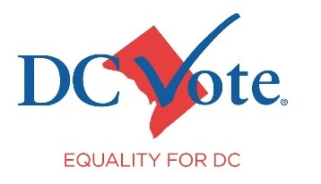
Fact Sheet: DC Statehood Bill

The Challenge: Democracy Denied
For more than 220 years, the nearly 700,000 residents of Washington, D.C., have been denied the voting representation in Congress and full local self-government that is the birthright of all American citizens. Despite fulfilling all the obligations of citizenship, including paying federal taxes and serving in the armed forces, D.C. residents remain without a vote in Congress.

Key Facts:
- D.C. has a population larger than that of two states, yet its residents have no voting members in Congress.
- D.C. residents elect a Delegate to the U.S. House of Representatives who can only participate in debates.
- D.C. residents have no representation in the Senate.
- D.C. residents pay more federal taxes per capita than any state and pay more federal taxes than 20 states.

The Solution: DC Statehood
Granting statehood to Washington, D.C., would provide its residents with voting representation and full local self-government. The Washington, D.C. Admission Act (“DC Statehood Bill”) would admit the State of Washington, Douglass Commonwealth into the Union and reduce the size of the federal district.

The state would consist of the residential and commercial areas of present-day D.C. The federal district, which will continue to belong to all Americans and be under Congress' control, would include the Capitol Complex, White House, Supreme Court, principal federal monuments, and National Mall.

Constitutionality and Fiscal Strength
The DC Admissions Act is constitutionally sound, leveraging the Admissions Clause, which grants Congress the authority to admit new states. In fact, all 37 new states were admitted by Congress, and none have been admitted by constitutional amendment. The bill also respects the District Clause, allowing Congress to adjust the size of the federal district. Additionally, D.C.'s strong economy, with a gross domestic product larger than that of 17 states, and its overwhelming support for statehood (86% of voters favored it in 2016) affirm its readiness for statehood. This bill would also repeal the enabling act for the 23rd Amendment, which assigns electoral college votes to the federal district. Repeal of the enabling act would, in turn, enable the repeal of the 23rd Amendment itself.

Current Status
The Washington, D.C. Admission Act (H.R.51) has passed the House twice. The bill has been reintroduced in both the House and the Senate in the 119th Congress.

