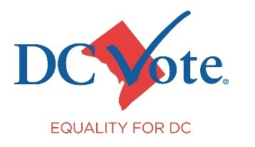
DC Home Rule Fact Sheet
Americans living in our nation’s capital, Washington, D.C., were granted limited local democracy – “home rule” in 1973. Since that time, however, Congress has consistently violated the spirit of that legislation. Those violations reinforce the need for Congress to make DC the 51st state.

Background
For most of Washington, D.C.’s history, DC residents had little to no say in the selection of their local leaders and virtually no input on their local laws or budget. That finally changed with the passage of the Home Rule Act. Under the Act, DC residents elect a Mayor, a 13-member Council and, since 2014, an Attorney General. The latter handles primarily civil cases. The federal government retains control of DC’s court and the office of the prosecutor.
DC is allowed to pass laws, but those laws are subject to a review period of 30 days for most legislation and 60 days for crime-related legislation. DC’s local budget, funded mostly by local tax dollars, must go through the congressional appropriations process. Additionally, DC’s power to raise revenue is restricted. For example, DC may not tax income earned in the District by citizens who live in neighboring states, cannot impose tolls on commuters, and has a congressionally mandated height limit for its buildings.

Inefficiencies and Interference
The congressional review process causes needless delays as DC residents must wait, often for months, before laws passed by their duly elected leaders take effect. The DC government deals with this flaw by passing emergency legislation. This is greatly inefficient, which is why no state in the United States has adopted this practice for their capital.

Members of Congress routinely seek to interfere in DC’s local laws, often through the appropriations process. For example, that process has been used to prevent the spending of local funds on a needle exchange program and on the commercialization of marijuana. There have been recent attempts to overturn locally passed laws on crime, elections, and other issues, including a successful effort to block the city’s effort to revise its outdated criminal code in 2022. The threat of interference is growing every year with more anti-home rule bills introduced in the last Congress than ever before.

Equality in DC
Members of Congress have an opportunity to support equality in DC by rejecting any attempts to interfere in how DC residents govern themselves and choose to spend their local dollars.

Given how often that inference occurs, however, the best way for Congress to ensure that DC residents enjoy the same local democracy and national representation is by passing the D.C. Admission Act, H.R. 51 and S.51.

